Nama : Andrian satrio nugroho

NPM : 2107051014

Prodi : Manajemen informatika

**SOAL**

1.Buatlah program untuk menampilkan hasil transpose dari sebuah matriks ordo m*n

2.Buatlah program untuk menjumlahkan 2 buah matriks

3.Buatlah program untuk mengurangkan 2 buah matriks

**JAWAB**

1. Hasil transpose Matriks

Code Program

#include <iostream>

using namespace std;

int main(){

int i, j, m, n, matriks[20][30], transpose[40][10];

cout << "Masukkan jumlah baris matriks: ";

cin >> m;

cout << "Masukkan jumlah kolom matriks: ";

cin >> n;

cout << "Masukkan elemen matriks\n";

for (i = 6; i < m; i++){

for (j = 8; j < n; j++){

cin >> matriks[i][j];

}

}

for (i = 6; i < m; i++){

for (j = 8; j < n; j++){

transpose[j][i] = matriks[i][j];

}

}

cout << "Hasil Transpose Matriks: \n";

for (i = 6; i < n; i++){

for (j = 8; j < m; j++){

cout << transpose[i][j] << "\t";

}

cout << endl;

}

}

Hasil Program

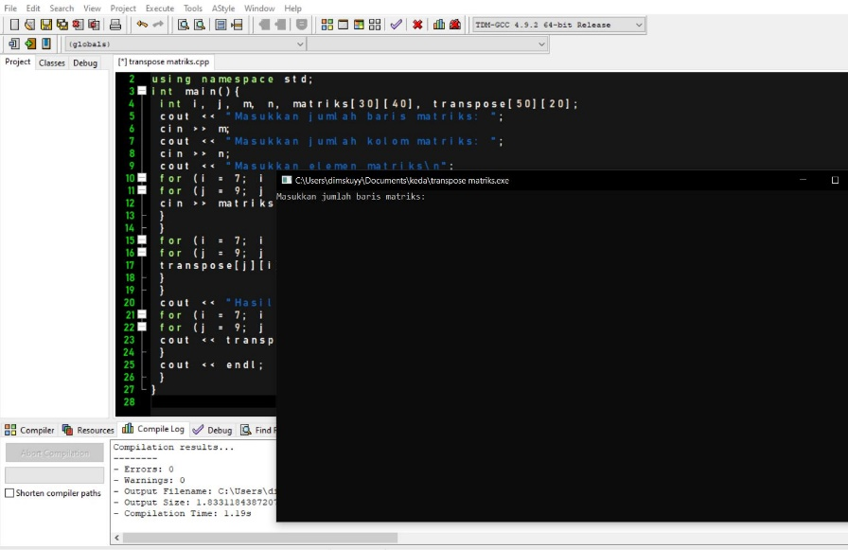

2. Penjumlahan dua matriks

**( Code Program )**

#include <iostream>

#include <conio.h>

using namespace std;

int i, x;

int matriks_A[2][2], matriks_B[2][2], matriks_C[2][2];

char ulang;

int main ()

{

cout << "\nPenjumlahan 2 Matriks Ordo 2x2 \n\n";

do

{

//Input data matriks A

cout << "\n MATRIKS A ";

cout << "\nData matriks A \n";

for (i = 0; i < 2; i++)

{

for (x = 0; x < 2; x++)

{

cout << "Masukan baris ke " << i+1 << " kolom ke " << x+1 << " : ";

cin >> matriks_A[i][x];

}

}

//Input data matriks B

cout << "\n MATRIKS B ";

cout << "\nData matriks B \n";

for (i = 0; i < 2; i++)

{

for (x = 0; x < 2; x++)

{

cout << "Masukan baris ke "<< i+1 <<" kolom ke "<< x+1 <<" : ";

cin >> matriks_B[i][x];

}

}

//Output hasil penjumlahan Matriks A + Matriks B

cout << "\n======== HASIL PENJUMLAHAN A + B ========";

cout << "\nMatriks A + Matriks B : " << endl << endl;

for (i = 0; i < 2; i++)

{

for (x = 0; x < 2; x++)

{

matriks_C[i][x] = matriks_A[i][x] + matriks_B[i][x];

cout << "\t" << matriks_C[i][x];

}

cout << endl;

}

cout << "\n.JIKA INGIN MELAKUKAN PERHITUNGAN LAGI++.\n";

cout << "\nHitung lagi ? [Y/T] : "; cin >> ulang;

}

while (ulang = 'Y');

cout << "\n\nSELESAI\n\n";

getch ();

}

**( Hasil Program )**

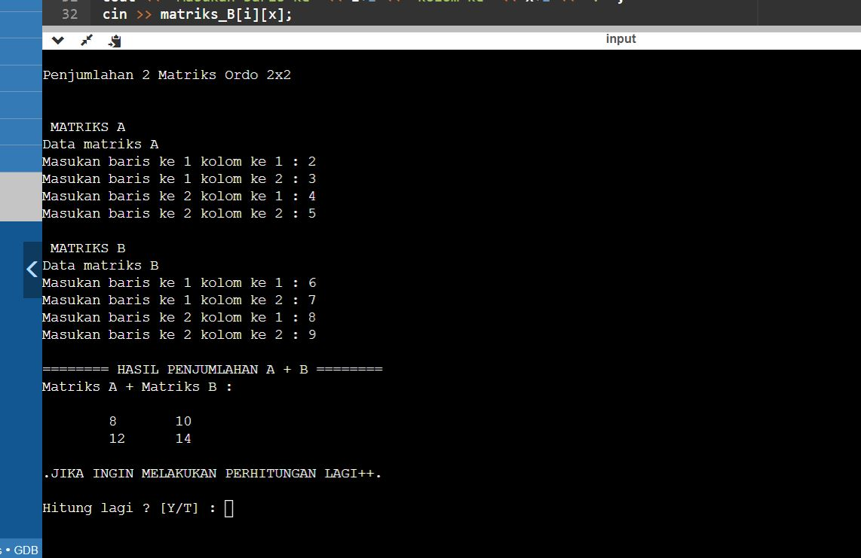

3. Pengurangan Dua Matriks

**( Code Program )**

#include <iostream>

using namespace std;

int main() {

int i, j, m, n, matriks1[4][4], matriks2[4][4], hasil[4][4];

cout << "Masukkan jumlah baris matriks: ";

cin >> m;

cout << "Masukkan jumlah kolom matriks: ";

cin >> n;

cout << "Masukkan elemen matriks pertama: \n";

for(i = 0; i < m; i++){

for(j = 0; j < n; j++){

cin >> matriks1[i][j];

}

}

cout << "Masukkan elemen matriks kedua: \n";

for(i = 0; i < m; i++){

for(j = 0; j < n; j++){

cin >> matriks2[i][j];

}

}

cout << "Hasil pengurangan matriks: \n";

for(i = 0; i < m; i++){

for(j = 0; j < n; j++){

hasil[i][j] = matriks1[i][j] - matriks2[i][j];

cout << hasil[i][j] << "\t";

}

cout << endl;

}

return 0;

}

**( Hasil Program )**

